****

**Addition, Kitchen & Bath Specialists**

**665 North Broad Street – Woodbury, NJ 08096**

**PHONE** (856) 853-8398 **FAX** (856) 853-4808 **EMAIL** matts@ciprianibuilders.com

Date: May 8, 2017

CIPRIANI BUILDERS INC. T/A CIPRIANI REMODELING SOLUTIONS

N.J. HOME BUILDER REGISTRATION # 020119

N.J. HOME IMPROVEMENT CONTRACTOR REGISTRATION # 13VH00028600

Owner's Name: Ken Hyun and Salina Wydo

Site Address: 14 Callison Lane

City: Voorhees, NJ 08043

Phone: 330-631-7063 (Salina Cell) 330-631-6881 (Ken Cell)

email: smwydo@gmail.com; kenhyun@gmail.com

**THIS AGREEMENT IS BETWEEN THE BUILDER AND THE OWNER AS NOTED ABOVE AND BOTH PARTIES AGREE TO THE FOLLOWING SPECIFICATIONS:**

**PROJECT SUMMARY**

Kitchen and Powder Room Remodel

**PLANS AND PERMITS**

The owner is responsible for the cost of the Township's permit and or survey fees.

The Builder will execute the necessary administrative work associated with the permitting and will also schedule all inspections for the project.

**AREA PREPARATION**

The owner is responsible to remove all personal items from the work area such as furniture or decorations and store them away for the duration of the job. The owner is also responsible to arrange for the return of those items if desired.

We will not be responsible for any damage to personal property left in the work area or for items that company employees have to move for you.

The owner should disconnect any computers or electronics that are vulnerable to damage due to construction-related fluctuations in electrical service. Cipriani Remodeling Solutions, assumes no responsibility for these items.

Please notify the builder in writing of any electrical appliances or equipment that require uninterrupted electrical supply such as sump pumps, ejector pumps, refrigerators, freezers, electronics etc. During the course of the project, please check these items daily to ensure that they are functioning properly. It is possible that a circuit can be inadvertently and unknowingly shut down during construction.

The owner should remove items hanging on walls, in the general proximity of the work so they are not damaged during construction.

The owner is responsible to allow for storage area on the property for the storage of materials and equipment.

There will be some inevitable inconveniences during the project. Efforts will be made to minimize these and to notify the owner of their occurrence as the need arises.

During the project, there could be times when the electricity, phone, water or HVAC may be temporarily interrupted. Every effort will be made to notify the owner prior to this occurrence.

**DUST PROTECTION**

We will take reasonable precautions to protect the property from dirt and dust that may be generated during the project. Please note that some dust may infiltrate our dust protection.

An appropriate dust and property protection plan will be established by the project manager during the preconstruction conference.

The owner should cover any personal items during the course of the project to aid in controlling the dust generated by the work.

**INTERIOR DEMOLITION**

We will perform the following interior demolition work to prepare the area for the new changes.

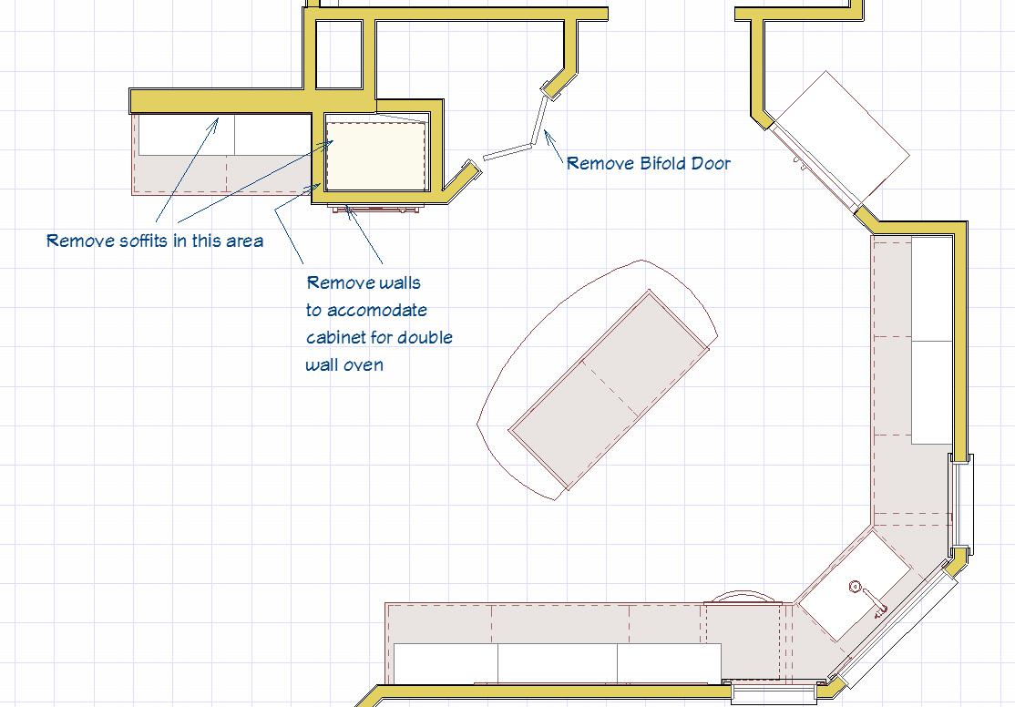

Remove the existing kitchen cabinets, counter tops, sink, faucet, and appliances.

Remove the existing cabinets, countertops, fixtures, and mirror.

Location: Powder Room

Location to store unused appliances: Put wall oven and refrigerator aside for owner.

Appliances to be put at curb: Cooktop, dishwasher, trash compactor

Remove the existing floor coverings to sub floor.

Sq. Ft.: Approx. 1700

Location: Entire 1st Floor except for the front office

Remove the existing electrical work as needed.

Including: Ceiling fan, track lighting, wall speaker unit, and 3 phone jacks

Location: Kitchen and Powder Room

Remove the existing plumbing as needed.

Location: Kitchen and Powder Room

Remove the existing interior walls.

Lineal feet of wall: 6’

Location: Kitchen wall oven area

Remove the existing interior trim as needed for wall removal.

Location: Kitchen

Remove the existing kitchen and Powder Room soffits. (Soffit above refrigerator to remain in kitchen)

Lin. Ft.: Approx. 8’ in kitchen, and 10’ in powder room

Location: Kitchen and Powder Room

NOTE: Agreement is based on soffits having no mechanicals or other items needing to be removed. If obstacles are found when soffits are opened up a change order will be written for the additional costs.

Remove Wall Paper.

Location: Powder Room

**WALL FRAMING**

We will furnish and install 2x4 interior wall at 16” on center per the new plans as needed.

Locations: Where wall around double wall oven is removed and above refrigerator to shrink the size of the opening where the cabinet over the fridge currently is.

When new framing is attached to an existing structure, it is not always possible to provide an even transition between the old and new. All structures settle over time and are often no longer level or plumb. Every effort will be made to make the transitions as smooth and unnoticeable as possible. This may entail adjusting the new framing to be out of plumb or level to match to the existing.

**WASTE REMOVAL**

We will remove the construction debris from the job site by placing a dumpster on the property.

NOTE: Please do not place personal refuse in the dumpster or allow others to without first consulting the project manager. Please notify your project manager as soon as possible if you see any unauthorized use of the container.

Dumpster Location: Driveway

NOTE: Many municipalities have restrictions and/or fees associated with placing dumpsters in the street. In some municipalities, the placement of refuse containers in the street is prohibited.

**ELECTRIC PANEL**

The existing electrical panel will remain.

The existing electric panel appears to be adequate for the additional electrical requirements of the project. However, the final calculations will be performed by a licensed electrician when the electrical work begins. If at that time it is determined there is a insufficiency with the capacity or condition of the existing service, we will quote a price in the form of a change order for the additional work required to upgrade the panel as needed.

**ELECTRIC**

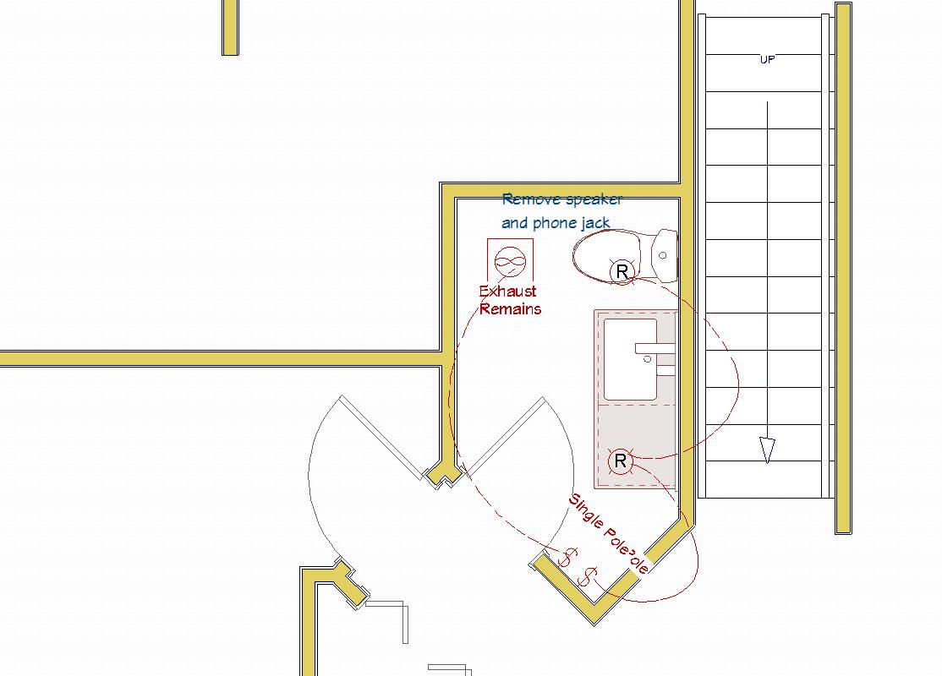

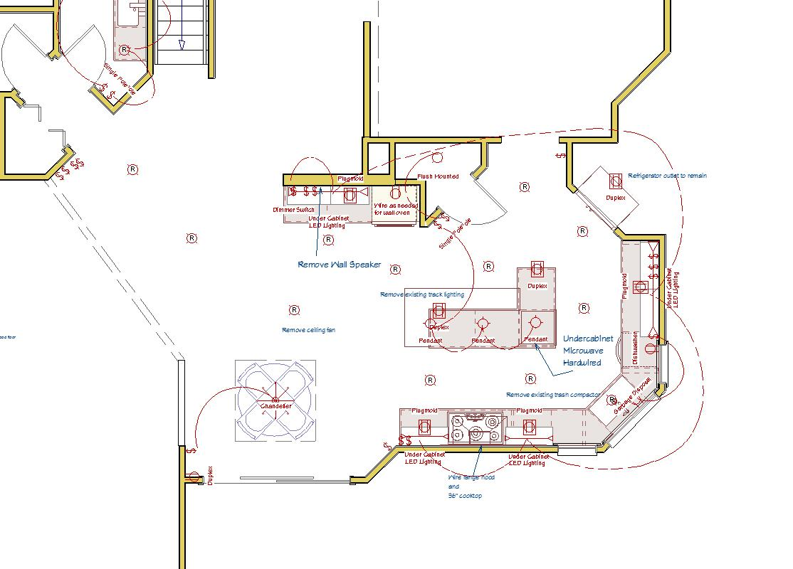

If aluminum wiring is discovered in the work area, a new circuit must be installed to the electrical panel. An additional cost will be presented to you in the form of a written change order before this work is addressed.

We will install the following electric devices and fixtures:

OUTLETS

15 Linear Feet of Plugmold Receptacles Under Wall Cabinets to replace existing outlets

2 Island Outlets

1 Replace duplex wall receptacle for color or age by dining area

1 Replace GFCI in Powder Room due to color or age

SWITCHES

14 Switches will be installed to replace existing switches, and will be used to control the recess and pendant lights. Included in that count will be 4 dimmer switches (Recess light placement and switch location to be determined)

1 L.E.D. dimmer switch for Under Cabinet Lighting

1 Switch for pantry closet

1 Switch for chandelier light

2 Replace 2 switches in the Powder Room due to color or age

LIGHTING

3 Pendant Light Boxes--Fixtures by Owner

11 LED Recessed lights, 5”, white step baffle --Fixtures by CRS

15 Ln. Ft. of under-cabinet lights--Low Voltage--Fixtures by CRS

2 LED Recessed lights, 4”, white step baffle – Fixtures by CRS (Powder Room)

1 Chandelier Light Box—Fixture By Owner

1 Surface mount light fixture in pantry closet – Fixture by Owner

FANS/VENTILATION

(BATH EXHAUST FANS MUST BE VENTED TO THE OUTSIDE AND CAN CAUSE MINOR DRAFTS)

1 Hood--Unit by Owner

APPLIANCES

1 Refrigerator will be reconnected to the existing wiring

1 Electric Cook Top

1 Double Wall Oven

1 Microwave Drawer

1 Dishwasher

Color of the outlets, switches and plate covers: White

Switches and outlets will be used: Decora Style

New circuits will be installed as needed.

**PLUMBING**

We will supply and install the necessary copper or pex supply and waste lines as required for the following items.

Kitchen: Sink with new shut-off valves and trap in the existing location

Dishwasher

Ice Maker Water Line

Powder Room: Sink with new shut-off valves and trap in the existing location

Install new toilet

The existing hot water heater will remain.

\*We will tie into the existing soil and water systems in the area nearest to the new work and will not be responsible for the sizing and condition the existing pipes. If lead drain lines or other pipes that need further replacement are discovered, we will present a cost to the owner before doing the work.

**VENTILATION**

We will supply and install the necessary ducting to vent the owner's kitchen exhaust appliance to the outside of the building.

The existing vent fan will remain in the Powder Room

**DRYWALL**

Approx. 36 Sq. Ft. of ½” drywall to be installed to the walls and ceilings

(Nails will still be used on the perimeter of the sheets.)

Location: Kitchen and Powder Room Soffits and above refrigerator

Drywall installation in finished rooms will include corner metal, nails, and all finish taping work to make the new drywall ready for paint.

\*DRYWALL CHARACTERISTICS:

During the drywall phase of your project there may be times when the drywall dust will infiltrate our dust protection.

When the drywall is to be painted by the owner, there will be some normal touch up spackling and sanding or sponging that will have to be done in-between coats of paint by you or by your painter. It's highly recommended to use a flat, washable paint finish on the ceiling and walls.

WHEN INSTALLING DRYWALL OVER AN EXISTING SURFACE OR ON EXISTING FRAMING, THE BUILDER CANNOT CONTROL HOW PLUMB, LEVEL, SQUARE, OR EVEN THE EXISTING AREAS ARE. IN SOME CASES THIS MAY BE NOTICEABLE AFTER THE NEW WORK IS COMPLETE.

When a section of wall or ceiling is patched, or areas where new drywall is blended with existing drywall or plaster, the transition may be noticeable.

Usually within a year of completion, due to the natural shrinkage of framing materials, cracks can appear above windows and doors, seams may open up, and nail pops can occur with the best of drywall techniques. As the new wood dries out the material to which the drywall is attached moves. Please notify us if you notice these flaws developing. After a year has elapsed from the completion of your project, we will make repairs, however, the owner will be responsible for the touch up painting.

**KITCHEN CABINETS**

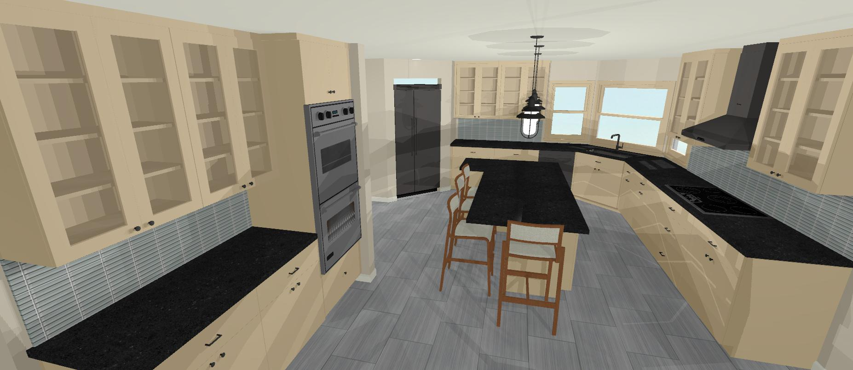 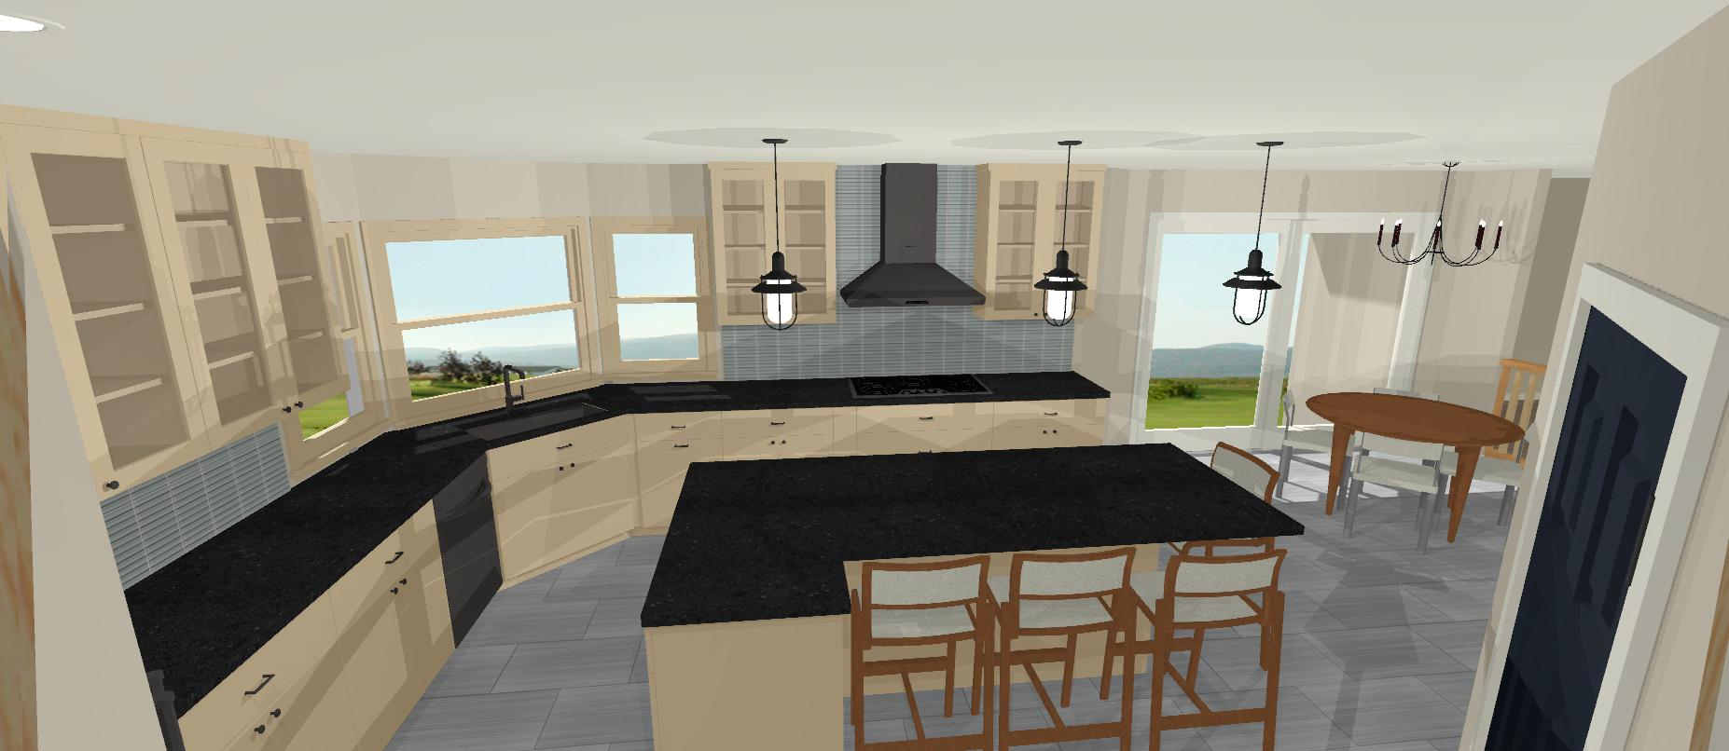 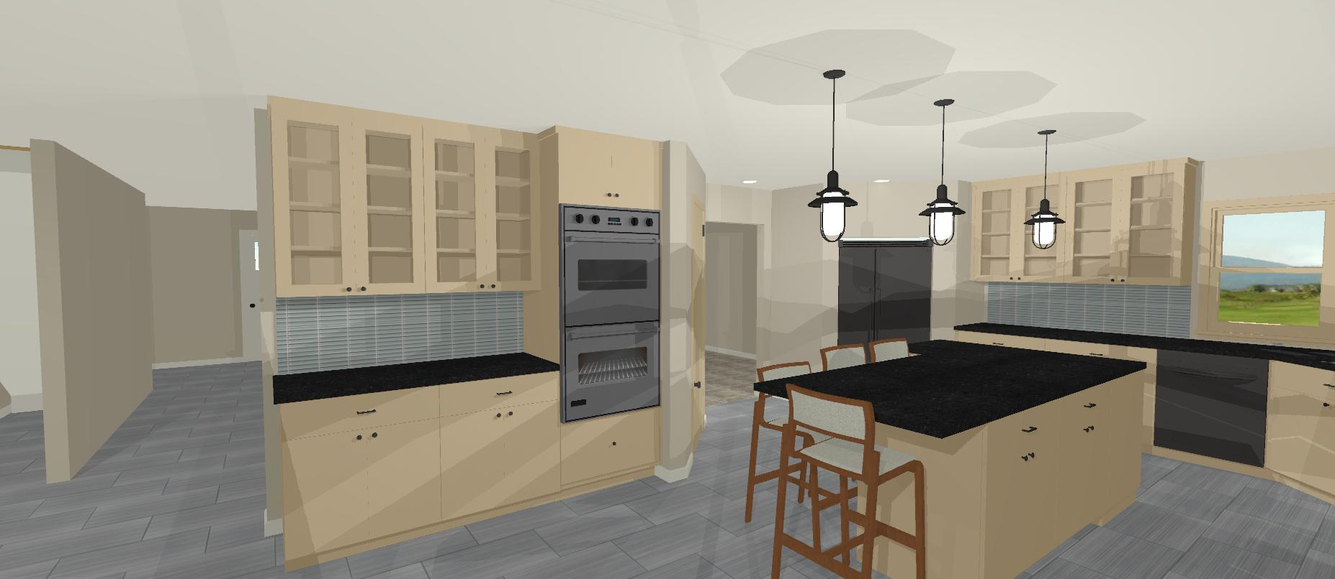 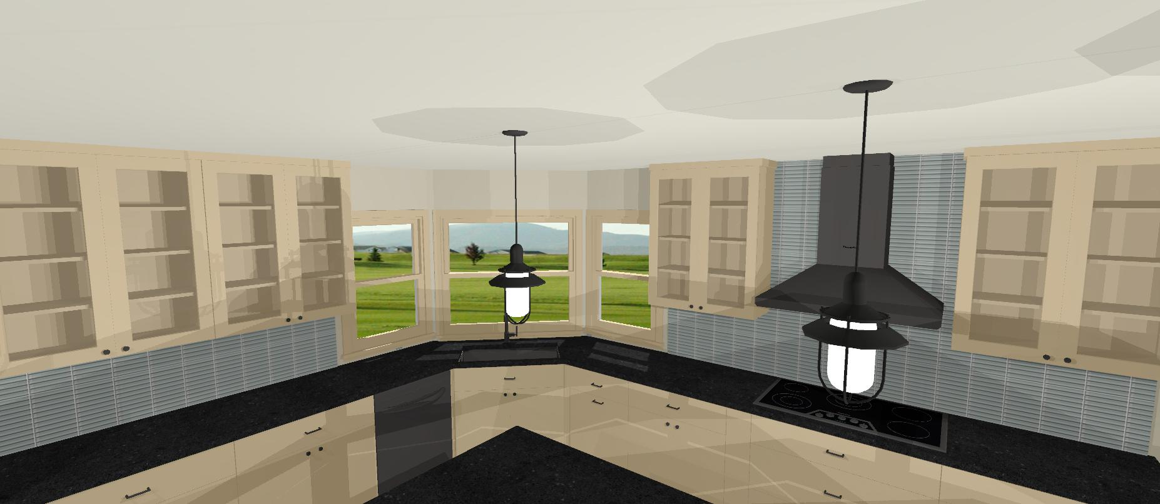We will furnish and install cabinetry in the kitchen as per plan.

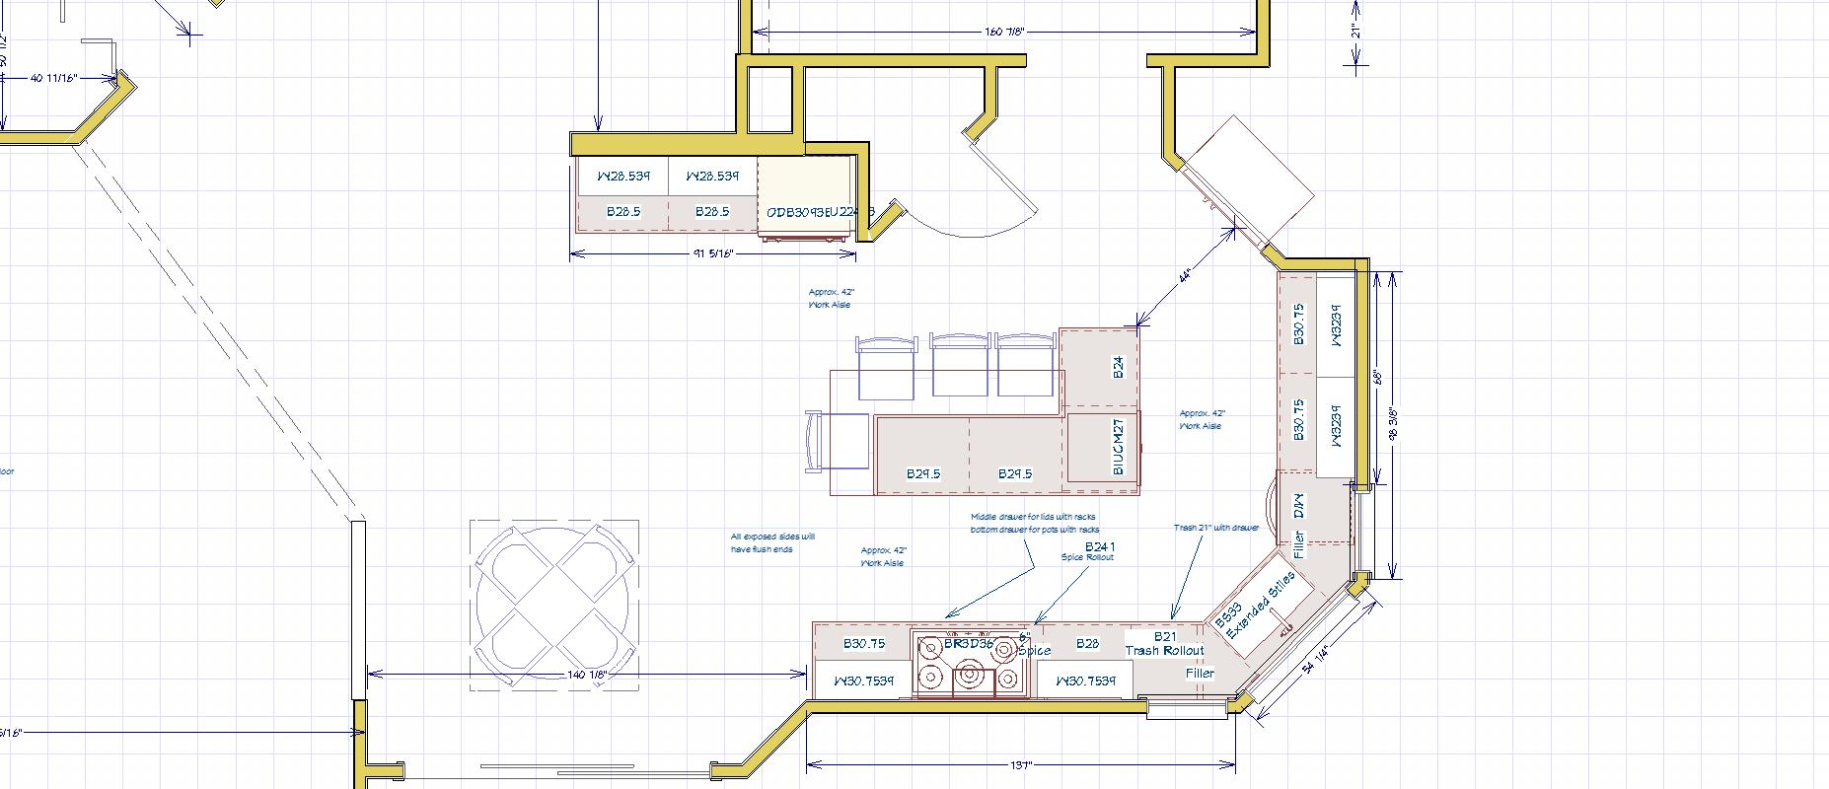

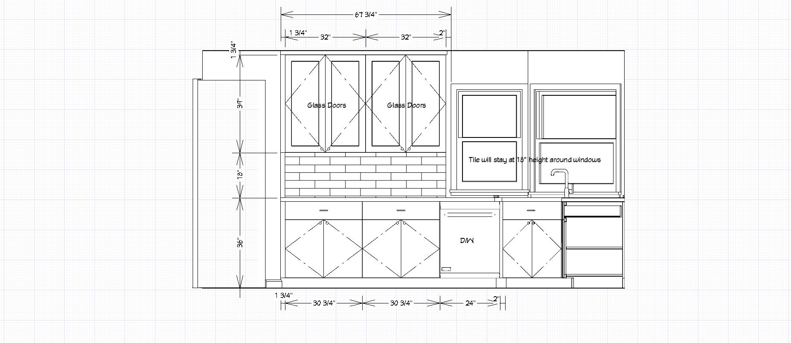

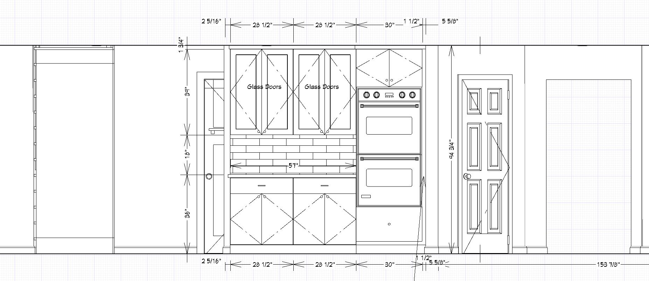

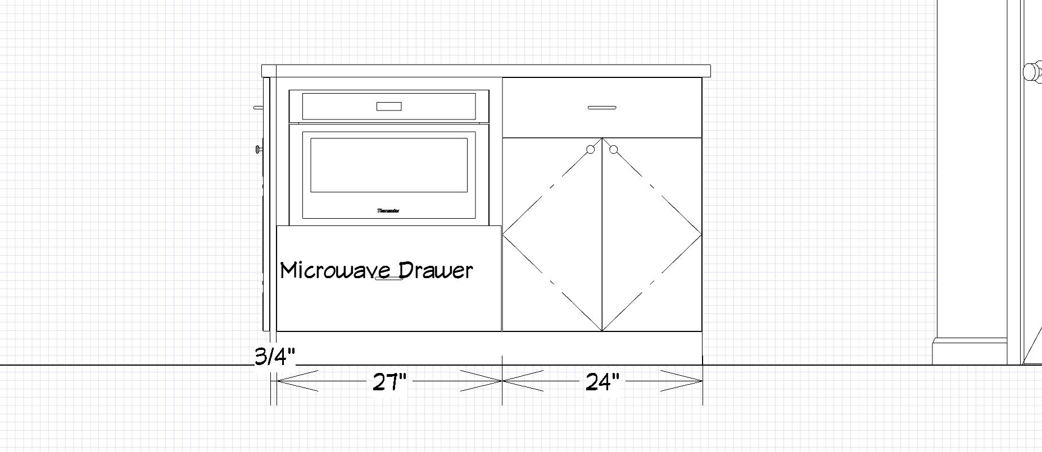

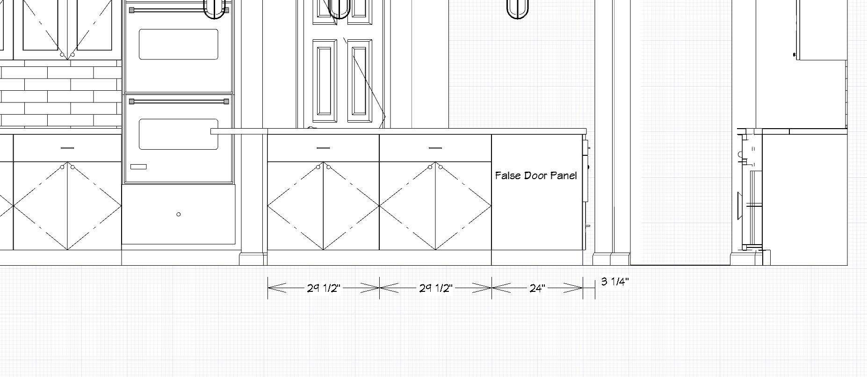

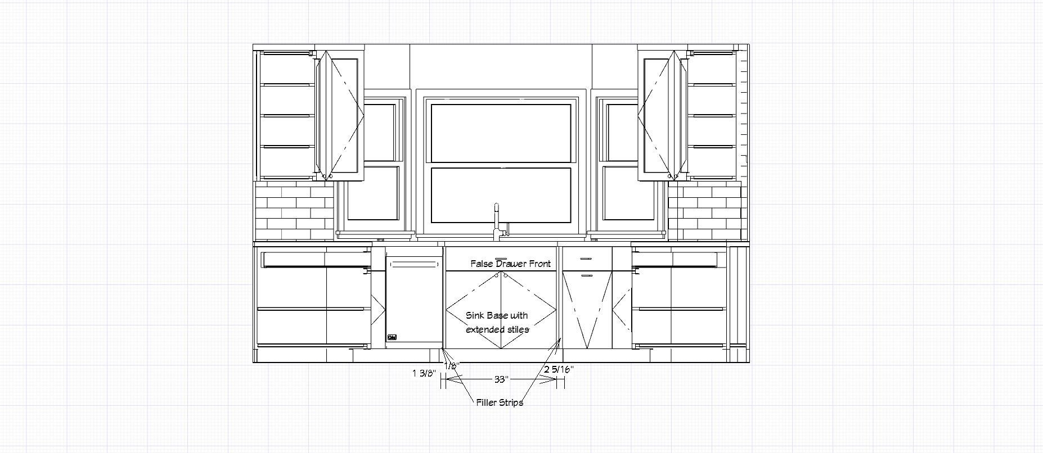

WOOD CHARACTERISTICS OF MAPLE: Closed grain off-white color with occasional dark mineral streaks. Will darken slightly with age.

Manufacturer of the cabinets: Conestoga Wood Specialties

Name of the cabinets: Advantage Series

Style of the base and tall cabinet doors: Astoria

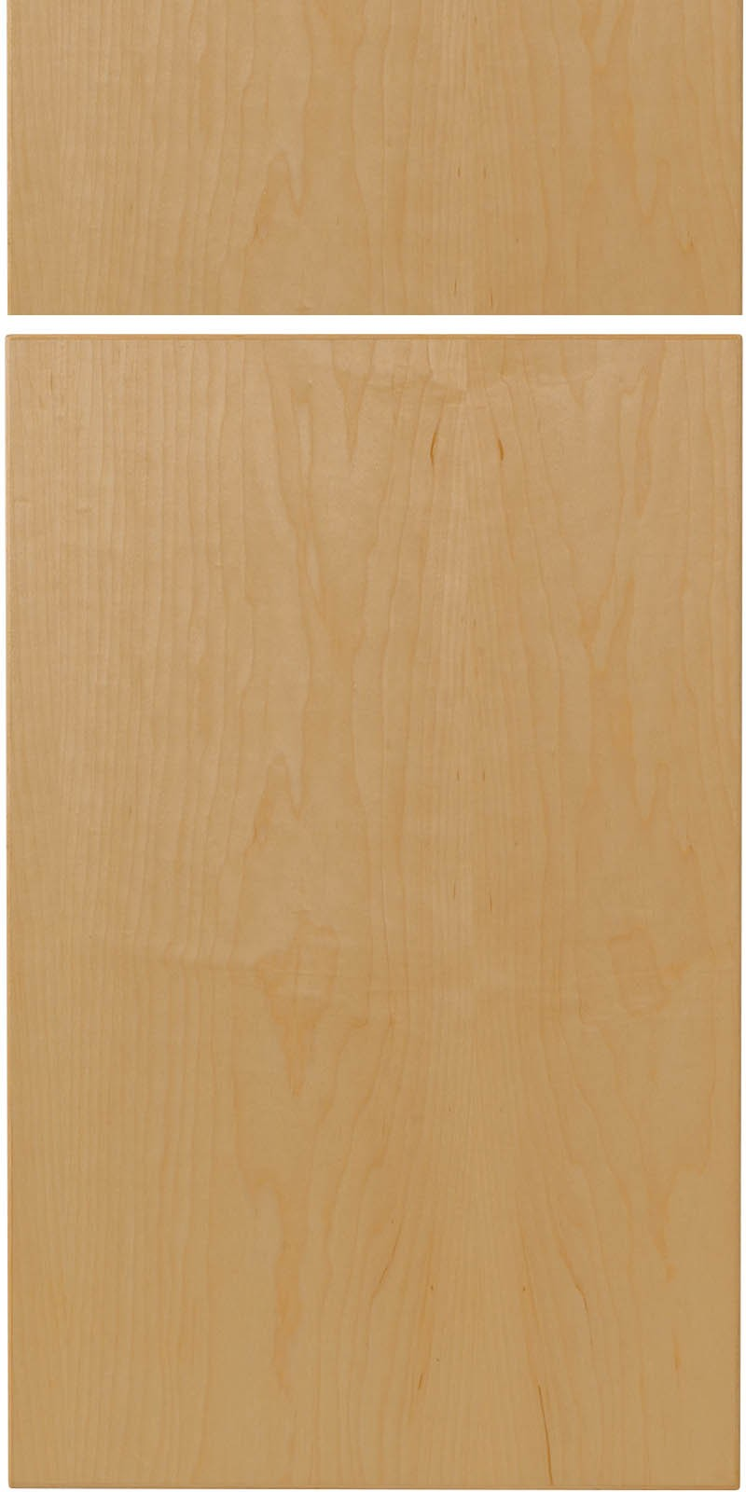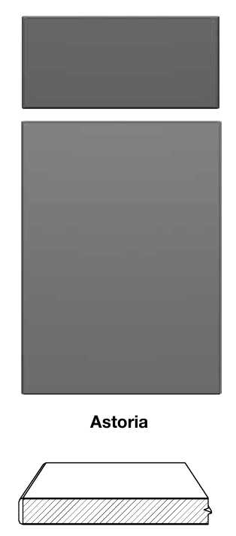

Style of the wall cabinets: Amesbury w/ clear glass panels

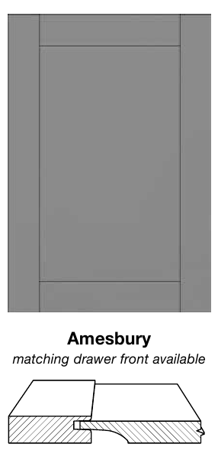 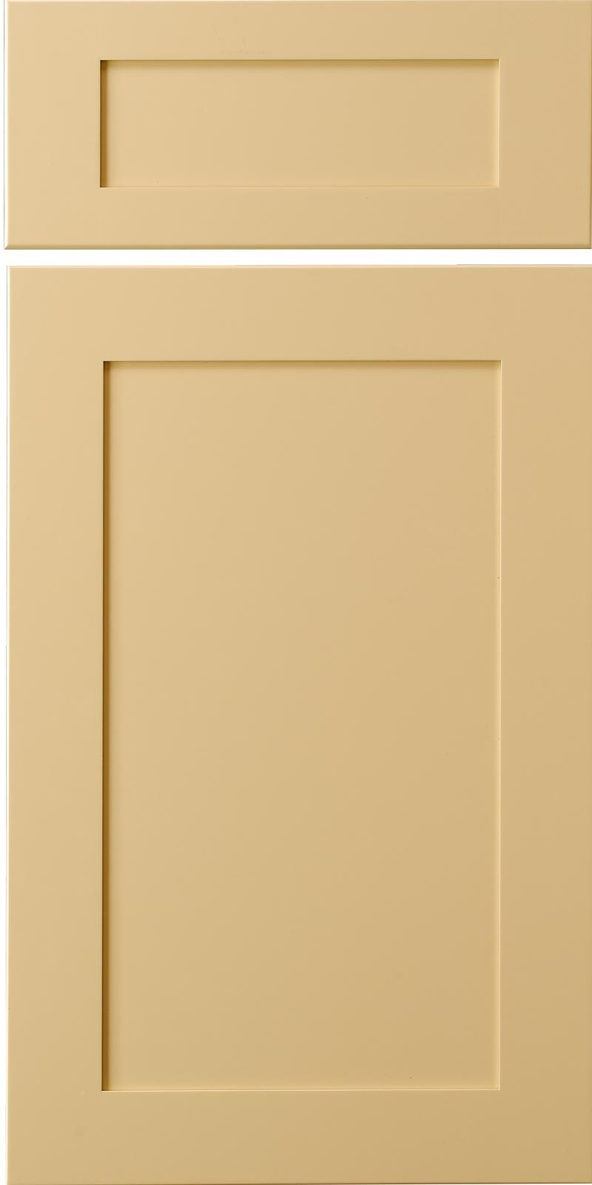

Wood species: Maple

Stain or color of the cabinets: Natural

Interior finish of cabinets: Natural Birch

Type of door / overlay: 3mm matching edgeband door with horizontal grain

1-1/4” (Full Overlay)

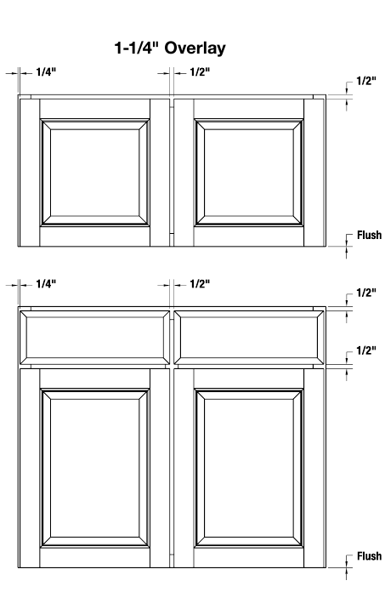

Knobs and Pulls: $4 allowance per knob and pull

Type of kick plate material: Wood

Pull outs: None

Sink front pop out: No

Crown molding: Frieze board to ceiling

Light Rail: None

Glass in doors: Wall Cabinets

Grills in Glass: None

Spice Pullout: Rev-A-Shelf 432-BFBBSC-6C Pull-Out Between Cabinet Base Filler with Ball-Bearing Soft-Close Slides, 6", Natural

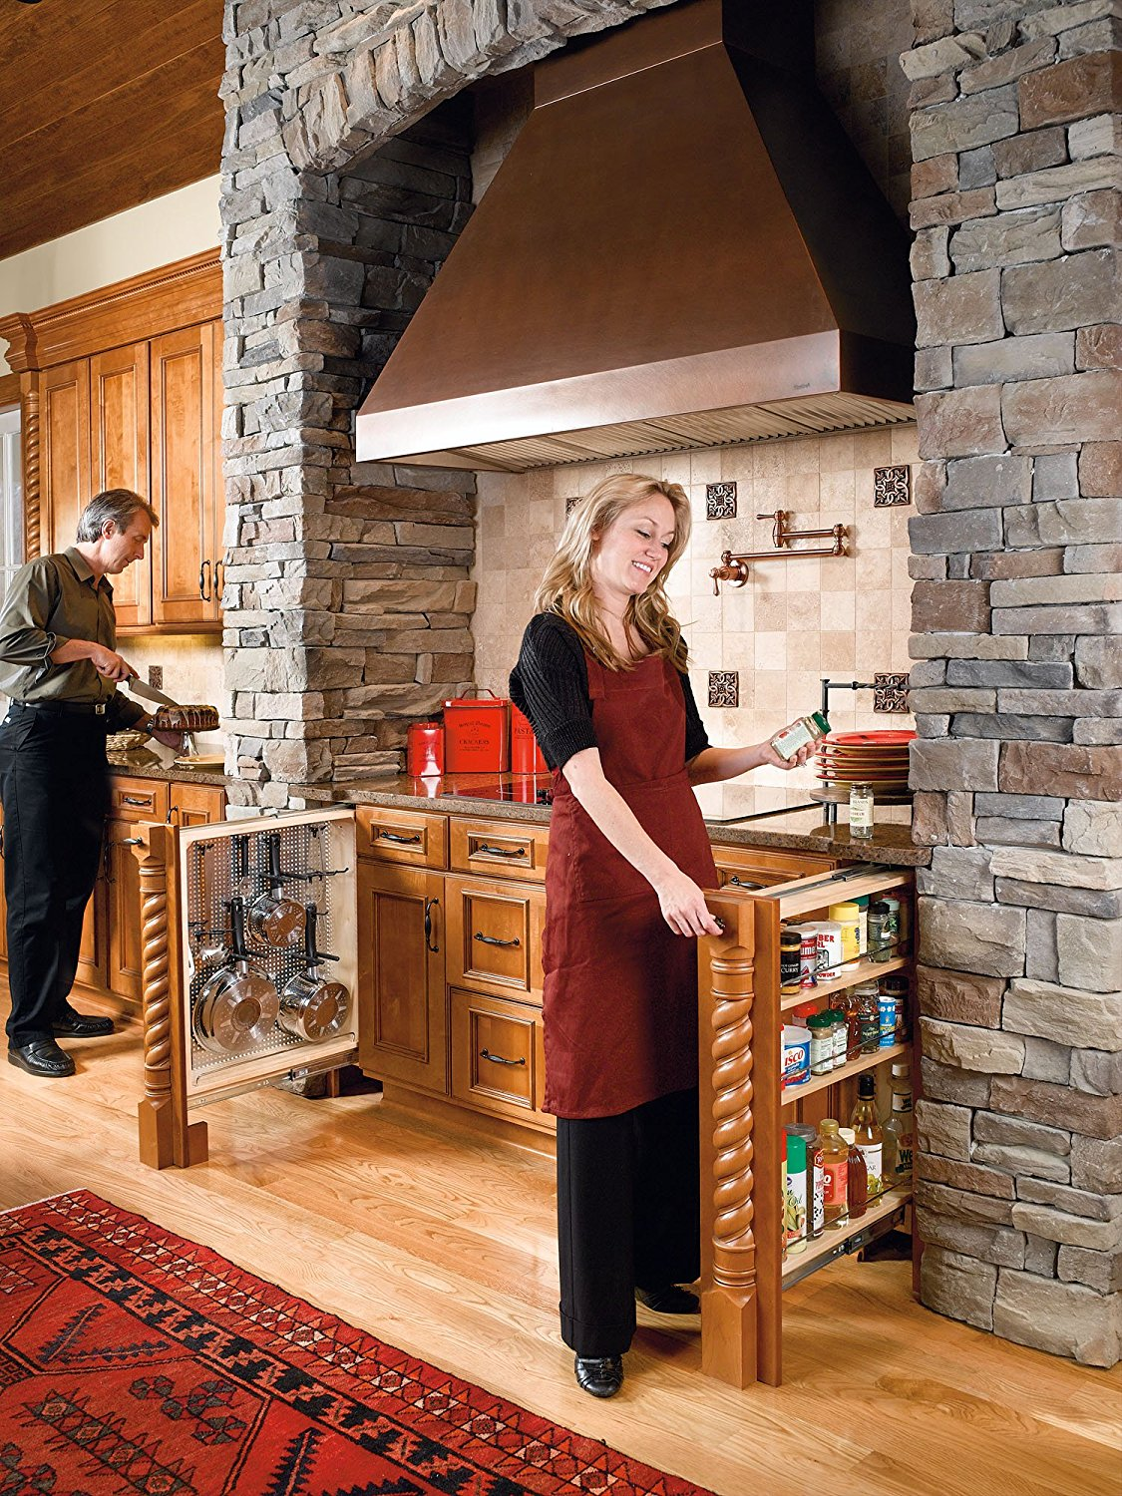

Trash Rollout: Rev-A-Shelf 4WCSC-2135DM-2 Double Pull-Out Bottom Mount Wood and Silver Waste Container with Soft-Close Slides, 35 quart, Natural

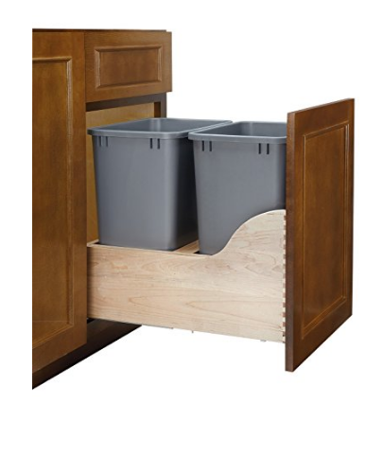

Wall oven size: 30” Wide

(3) Lid Organizers: Rev-A-Shelf - 5DLD-1-CR - Drop-in Lid Organizer for Drawer Peg Board System

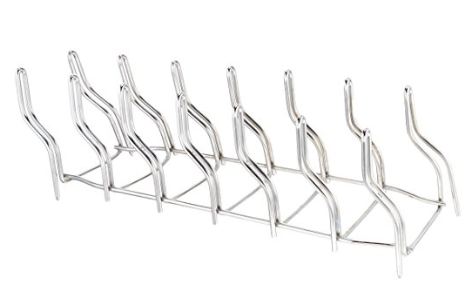

(3) Pot and Pan Organizers: Rev-a-Shelf SDCD-1-CR Pot/Pan Organizer

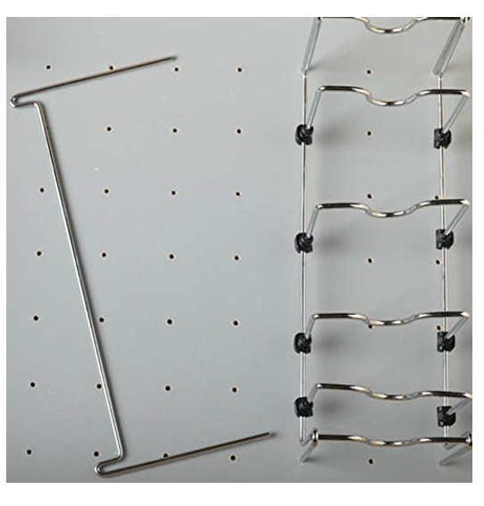

(2) Peg Board Organizers: Cut-To-Size Insert Peg System for Drawers - 4DPS-3921 - 39-1/4"W x 21-1/4"D x 6-5/8"H - Natural

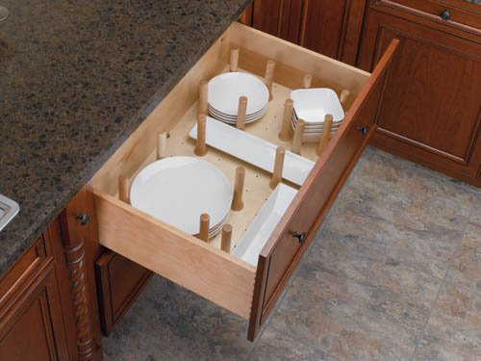

The Project Manager will determine on site whether the base cabinetry requires raising for optimum functionality.

Please note that the computer renderings of the kitchen are an illustration of the general appearance of the area. It is not meant to be an exact representation.

With wood cabinets, you should expect variations in wood grains, stain color, and knots. Normal expansion and contraction can cause visible lines at the joints on cabinet face frames and doors. This is the nature of wood products.

**COUNTER TOPS**:

We will furnish and install granite tops on the base cabinets in the Kitchen and Powder Room.

Color: Absolute Black



Finish: Polished

Type of edge treatment: Eased

Number of fixture holes in Kitchen countertop:1

Number of fixture holes in Powder Room countertop:1

4” Backsplash in Kitchen: None

3” Backsplash in Powder Room: Yes

You have chosen a natural stone for your project and because of the variations in color/ graining and the likelihood of small pits and fissures, we recommend that you inspect your slabs and the layout prior to the cutting of the stone. If you decide not to do this our fabricator will do it for you but we will not be responsible if you're not satisfied with the finished product.

Granite countertops generally require field seams. All seams that may be required are at the sole discretion of the fabricator.

Waiver for Personal Stone Inspection: I understand the characteristics of this material and waive my opportunity to personally inspect the product prior to fabrication. I authorize the use of stock material for my project and will not hold the builder or the fabricator liable for variances in the material as outlined above.

Customer Name:\_\_\_\_\_\_\_\_\_\_\_\_\_\_\_\_\_\_\_\_\_\_\_\_\_\_\_\_\_ Date:\_\_\_\_\_\_\_\_\_\_\_\_\_\_\_

Acceptance for Personal Stone Inspection: I understand the characteristics of this material and will exercise my opportunity to personally inspect the product prior to fabrication.

Customer Name:\_\_\_\_\_\_\_\_\_\_\_\_\_\_\_\_\_\_\_\_\_\_\_\_\_\_\_\_\_ Date:\_\_\_\_\_\_\_\_\_\_\_\_\_\_\_

**WALL BACKSPLASH**:

TILE BACKSPLASH - STANDARD LAYOUT

We will furnish and install the tile and setting materials as described below:

Tile Manufacturer and Model #(s): Element

Color(s):Mist

Size(s):3x12

Grout Color: Sterling

Layout: Staggered

SEE DRAWING BELOW FOR TILE LAYOUT.

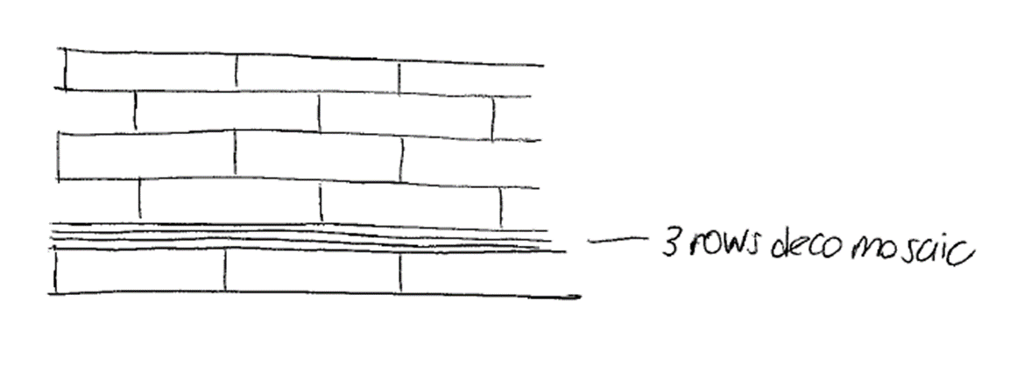

SEE CABINET ELEVATIONS IN “KITCHEN CABINET” SECTION FOR TILE LOCATIONS.

The tile will be set in a straight pattern using field tile with no accents. (standard layout)

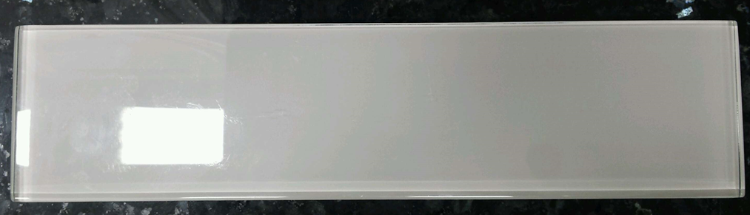

In tile installations with a "standard" layout the electrical switches and outlets that fall within the backsplash area will be placed for code compliance and the owner's convenience without regard for tile layout. (Standard layout design is with all tiles at right angles with the walls and countertops, and normally involves a single type of tile--no diagonals, listellos, accents, mosaics or borders.)

Tile will stay at 18” height except behind the range hood where it will go to the ceiling between the two adjacent cabinets.

**KITCHEN FIXTURES**:

We will furnish and install the following kitchen fixtures.

Sink make: Luxart

Sink model: LXZS772

Sink color or finish: Stainless

Sink size: 27” x 17”

Depth: 10”

Gauge: 16”

Bowl type: Undermount

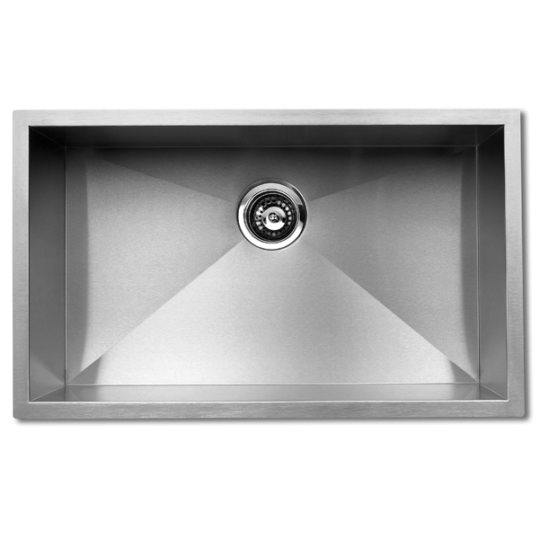

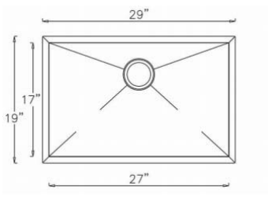

Faucet make: Delta

Faucet model: 9159-DST

Faucet color or finish: Polished Chrome

Faucet size: 15-11/16”

Faucet Allowance if other faucet chosen: $225

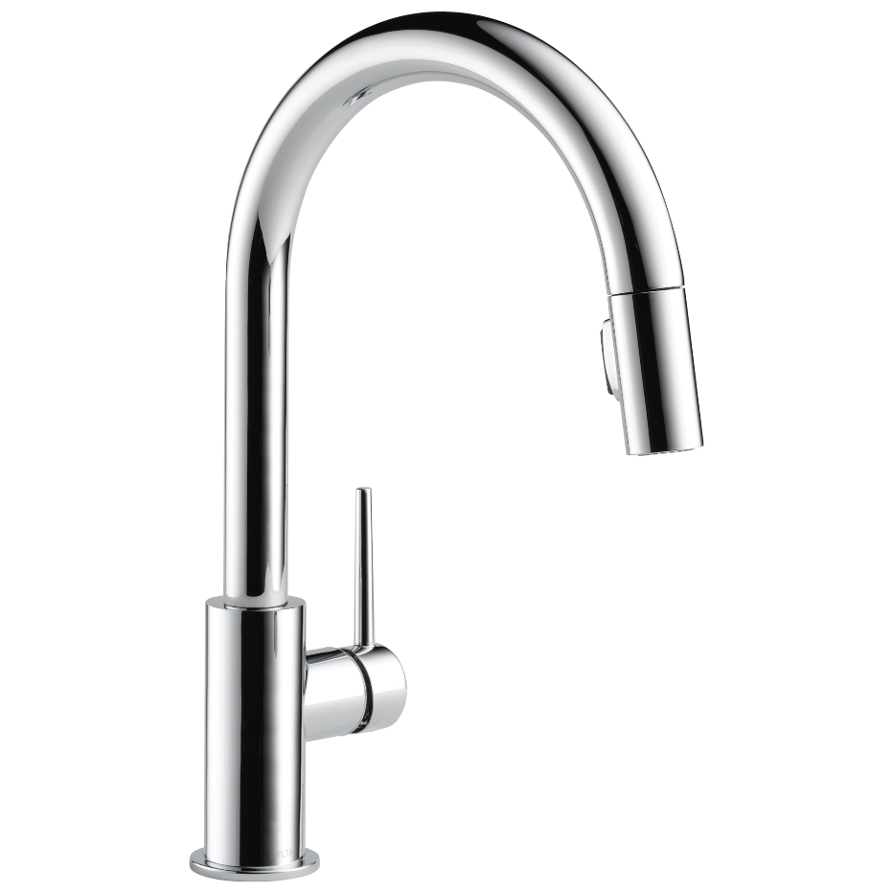

Garbage Disposal Make: Insinkerator

Model: Badger 5

Horsepower: 1/2



**POWDER ROOM FIXTURES**:

We will furnish and install the following powder room fixtures.

Sink make: Kohler

Sink model: K-2882-0

Sink color or finish: White

Sink size: Length: 17-1/4" (438 mm)

Width: 13" (330 mm)

Water depth: 3-1/8" (79 mm)

Bowl type: Undermount

Sink Allowance if other sink chosen: $115

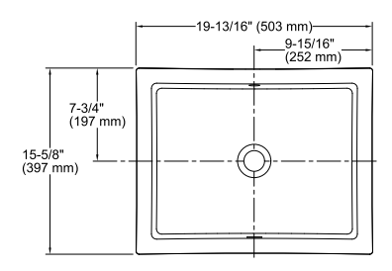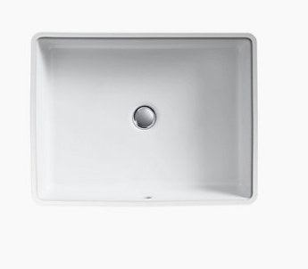

Faucet Make: Delta

Faucet model: 559LF-MPU

Faucet color or finish: Polished Chrome

Faucet size: 6-1/4”

Faucet Allowance if other faucet chosen: $120

 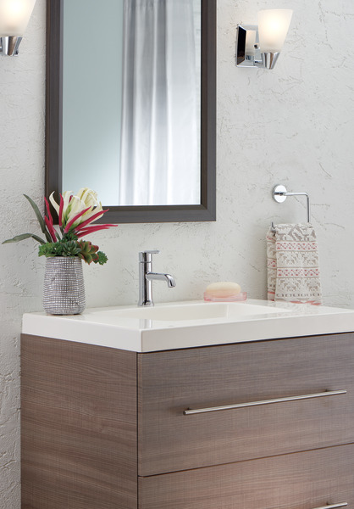

Toilet Make: Kohler

Toilet Model: K-3654-0

Toilet Seat: K-5774-0 Soft Close

Supply: Chrome

Allowance: $330

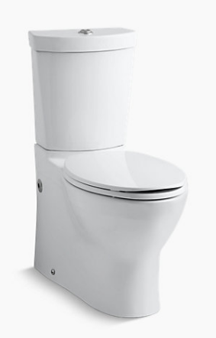 

Toilet Paper Holder

Make: Delta

Model: 75950

Allowance: $25

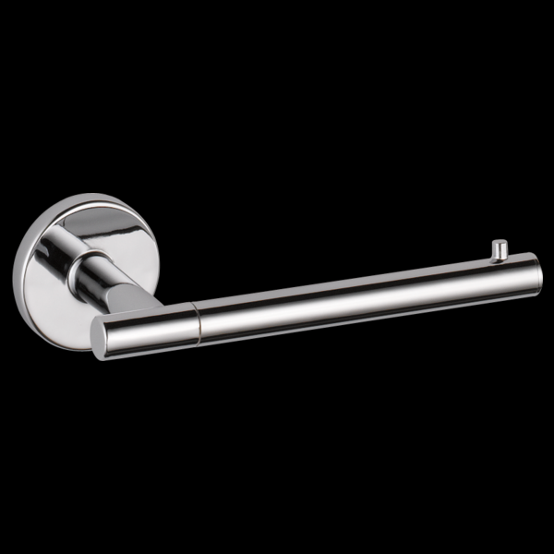

Towel Bar:

Make: Delta

Model: 75918

Allowance: $28

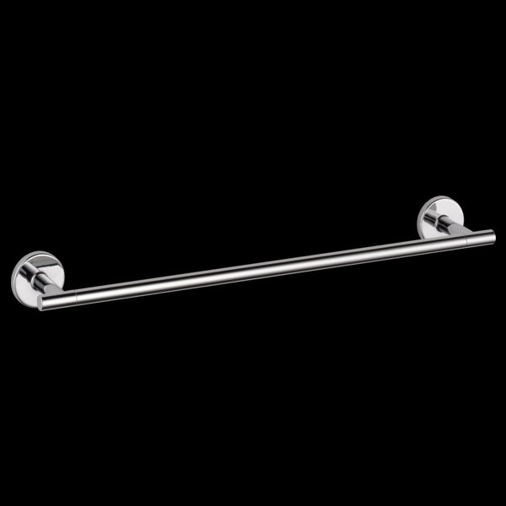

Vanity Cabinet:

WOOD CHARACTERISTICS OF MAPLE: Closed grain off-white color with occasional dark mineral streaks. Will darken slightly with age.

Manufacturer of the cabinets: Conestoga Wood Specialties

Name of the cabinets: Advantage Series

Style of the base and tall cabinet doors: Astoria

Size: 45W x 24H x 21D



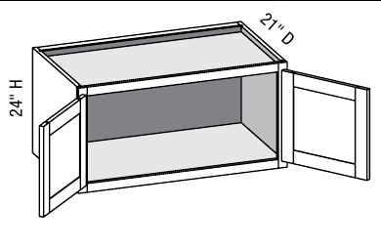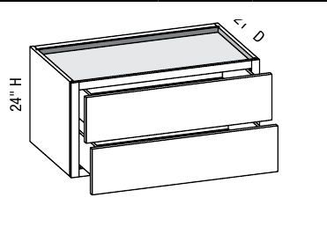

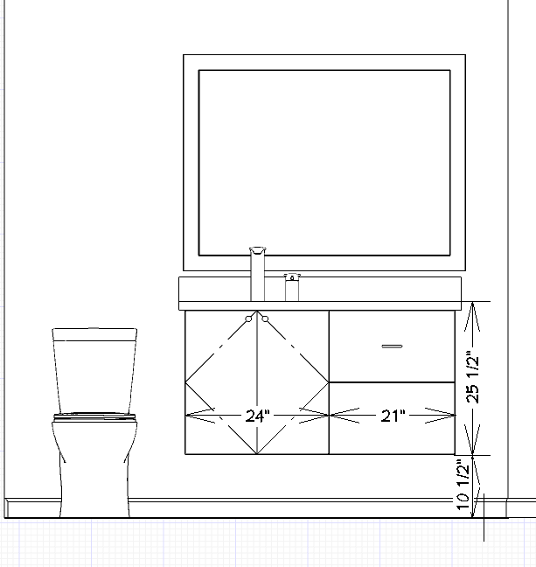

MIRROR:

Make: Conestoga

Detail: Matches Cabinetry

Size: 45’X36”

**APPLIANCES**:

While we will install the listed appliances, it is the owner's responsibility to purchase the appliances and coordinate their delivery to the job site.

It is critical that all owner-purchased appliances are either on site prior to the start of work, or the "cut sheets," describing all dimensional and mechanical requirements are made available to the project manager.

We have included the installation or reinstallation of the following appliances:

36” Electric Cook top

Double Electric Wall Oven

Under Cabinet 24” Microwave Drawer

36” Range Hood - OUTSIDE VENT (Exhaust ducted outside can result in minor air drafts)

Refrigerator w/water line

Dishwasher

Garbage Disposal

**INTERIOR TRIM**:

We will supply and install the following new trim in the areas in which we are working only:

Approx. QTY.

18 Ln. Ft. of Door casing (new pantry door)

Style: Sanitary

Type: Match Existing

Window sills:

Sills will be added to the existing kitchen window trim with no apron.

12 Ln. Ft. of Baseboard

Style: Sanitary

Type: Match Existing

The manner in which natural wood products accept staining cannot be controlled or predicted. Cipriani Remodeling Solutions is not responsible for how wood reacts to stain.

**INTERIOR DOORS**:

We will supply and install the following new interior door.

Location: Pantry Closet

Size: Approx. 32”

Type: Flush Hollow Core Door

Finish: Stained

If you wish to have door bumpers installed, you must supply them, and we will install them.

The manner in which natural wood products accept staining cannot be controlled or predicted. We are not responsible for how wood reacts to stain.

**FLOORING**:

BY OWNER

Cipriani Remodeling Solutions will remove existing marble tile and carpet on first floor.

New flooring will be installed after kitchen and powder room project is completed except for hardwood flooring in family room, which can be installed before they are complete.

**PAINTING INTERIOR**:

Areas to be painted: Kitchen and Powder Room

Walls: Flat Washable Finish

Ceiling: Flat Washable Finish

Windows: Trim to Remain as-is. Stain new sills added to kitchen windows

Doors: Stain new flush door

Trim: Stain new trim added to match existing trim

The use of semi-gloss or gloss on walls and ceilings is not recommended. Subtle irregularities in the framing, drywall, or plaster are always present to some degree. Glosses can accentuate those irregularities and render them more visible. Washable flat paints are an attractive and functional alternative.

Existing surfaces that are to be painted will be prepared by a light sanding, the filling of small holes (less than 1/2"), the repair of cracks (less than 1/8"), and the treatment of uneven surfaces with one coat of spackle, followed by a final sanding. The correction or repair of any major, unforeseen defects are not covered in this agreement. If such defects are found, the owner will be presented with a cost in the form of a change work order prior to commencing work.

The manner in which natural wood products accept staining cannot be controlled or predicted.

**GENERAL PROVISIONS**

The measurements and or dimensions shown on the plans, drawings or written in this agreement may vary slightly because of actual site conditions or unforeseen conditions.

Please note that the 3D computer drawings of the project are an artistic illustration of the general appearance of the floor plan and are not meant to be an exact representation of the final project appearance.

**HAZARDOUS MATERIALS (ASBESTOS, MOLD, AND RADON)**

The builders scope of work shall not include the identification, detection, abatement or removal of any asbestos, radon, mold, products/materials containing these or other hazardous substances from the building.

**CHANGES IN THE WORK DUE TO UNFORESEEN CIRCUMSTANCES OR CONDITIONS**

The parties acknowledge and agree that construction sometimes requires extra work due to concealed or differing site conditions not foreseen at the time of preparing the estimate or of the time of making of this agreement. Examples would include but are not limited to, termite and other wood-boring insect damage, water damage, wires, pipes, columns, hidden mechanical equipment, substandard prior work which must be upgraded to code, additional code requirements, owner not making prompt selections, concealed trash, rocks, stones tanks, stumps, and unforeseen subsurface soil conditions are some circumstances for which the Builder could incur additional costs.

The Parties agree to negotiate an equitable adjustment to the Contract Price and Contract Terms in the form of a Change Work Order in the event an unforeseen circumstance or condition is encountered.

The Change Work Order, written by the builder, shall describe the change in the scope of work, any related additional costs or credits and any changes to the completion date of the project. Both parties must sign the change order form. Payment for a Change Order shall be due before commencement of the Change in Work.

If no equitable adjustment can be negotiated in the form of a signed Change Work Order, either the Owner or the Builder may terminate this Contract. The balance due to the builder for the reasonable value of the labor and material furnished since the last progress payment made shall be paid, or if in dispute, submitted for determination by binding arbitration in accordance with the Contract Documents.

In the alternative, if no mutually satisfactory adjustments can be negotiated in the form of a signed Change Order, the parties may agree to jointly submit to binding arbitration the issue of equitable adjustments to the Contract Price and Contract Time for the Change in Work. The required Work shall thereafter continue. The cost to the Owner from a Change in Work in case of an Unforeseen Circumstance shall be due and owing from the Owner to Cipriani Remodeling Solutions promptly upon award by the arbitrator.

**CHANGE WORK ORDERS REQUESTED BY THE OWNER**

Without invalidating this agreement, the owner may add to, delete from or alter the work by requesting a Change Work Order.

The Change Work Order, written by the builder, shall describe the change in the scope of work, any related additional costs or credits and any changes to the completion date of the project. Both parties must sign the change order form. Payment for a Change Order shall be due before commencement of the Change in Work.

The owner should check the work completed each night and ask for any minor changes the following day. Some minor changes, if discovered promptly, may sometimes be performed with little or no additional costs. Failure to report these desired changes right away could create a problem that may affect other tasks, trade contractors, and schedules.

**ALLOWANCES AND SELECTIONS**

In special situations an allowance may be included in this agreement. This means that the owners have not made a final selection yet. It is assumed that the owner will make the final selection at a later date before the job has started. It is very important that these selections are made as soon as possible to avoid delays in ordering the materials needed to keep the job on schedule. Delays may create an increase in the cost of the job.

When an allowance amount is specified in this agreement, the following will apply:

If the cost of the customer-selected materials exceeds the material allowance amount, then that amount will be added to the next progress payment. If the amount is less than the allowance amount, then that amount will be subtracted from the final amount of the contract.

THE PROJECT CAN NOT BEGIN UNTIL ALL PRODUCTS ARE ORDERED. WE ASK THAT ALL SELECTIONS BE MADE BY THE TIME OF THE PRECONSTRUCTION MEETING. CIPRIANI REMODELING SOLUTIONS CANNOT COMMIT TO A START DATE, COMPLETION DATE OR A SCHEDULE UNTIL THESE SELECTIONS ARE GIVEN TO THE BUILDER IN WRITING.

**MATCHING FINISHES**

Cipriani Remodeling Solutions want the owner to be aware of the limitations of matching existing finishes. The Builder will try to match existing patterns, textures, colors, profiles, and planes, exact duplication cannot be promised or guaranteed.

**USE OF FACILITIES**

At the preconstruction meeting, arrangements can be discussed for how the builder will gain access to the house in the morning and secure the house at the end of the day if the owners are not home yet. Usually this can be accomplished by giving us a key to one of the doors, a garage door opener or by leaving a lock box on the door.

Normal work hours for field employees are 8:00am to 4:30pm Monday to Friday. Wednesdays may have an 8:30 start time.

The Owner agrees to provide us free use of all utilities to complete this job. Utilities used will include electricity, water and sometimes a restroom.

A portable "spot-a-pot" will be placed on the property for the duration of the job to allow the workmen to have access to restroom facilities without having to enter the house.

Are there any existing cracks in the driveway or sidewalks?

It is the owner's responsibility to allow areas for storage of materials. Please try to keep driveways clear and available for movement and parking of vehicles and/or equipment during normal work hours.

Workmen shall not be expected to keep doors and gates closed for pets or children.

**SAFETY**

The owner and their family members will need to be careful around the work site during and after work hours. There are times during a remodeling project when the site may present unsafe conditions. Inadequate or no light in the area, open flooring, exposed electric, and other hazards are likely at times during the course of your project. Avoid work areas if you are sensitive to VOC’s such as paints, glues and caulk.

**COMMUNICATION**

Cipriani Remodeling Solutions welcomes an open exchange of opinions and concerns to resolve any issues, should they develop. Good communication is important - don’t be afraid to ask questions.

**PAYMENT SCHEDULE**

Cipriani Remodeling Solutions payment schedule is designed to be fair to both the Owner and our company. Upon the start of each phase of the project, that portion will be due as per the payment schedule. The Project Manager will present to the owner a "PROGRESS PAYMENT REMINDER" at the beginning of each week which will indicate the payment schedule phase or phases that will be due by noon on Friday.

Near the completion of the project the owner and the Remodeling Consultant will review the completed work and fill out a Quality Control Punch List. This list is meant to establish a clear understanding of the list of items that need to be addressed and the total balance due to complete the job in accordance with the agreement. When the items on this list are completed, the final payment will be due. If there are any items on the punch list that cannot be finished due to materials being unavailable, the owner may hold back 150% of the value of that item until it is completed.

Any additional punch list items that are discovered after the QUALITY CONTROL PUNCH LIST work is done will be addressed and completed as a warranty item.

The costs shown on the owner's payment schedule do not reflect the cost of that phase of the project. They do, however, indicate a point in time by which costs are likely to have been incurred.

**The Home Owner agrees and understands that if The Home Owner finances the work with the Builder or a third party, any separate financing documents will include the number of monthly payments and the amount of each payment, including any finance charge.**

The Owner agrees and understands that in the event that the Owner does not pay the Builder any of the money owed when it is due, the Builder may have a claim against the owner that may be enforced against the property in accordance with applicable lien laws.

The Owner also understands that if they finance the work with the Builder or a third party, your separately provided financing documents may include a security interest. The Owner understands that they should read those documents closely.

**LIMITED WARRANTY**

Cipriani Remodeling Solutions will repair any defect directly attributed to workmanship for a period of three (3) years from the date the project is paid in full.

Materials provided by Cipriani Remodeling Solutions are covered under their own manufacturer's warranties which are in your packet. Please become familiar with your product warranties. While most manufacturers' warranties cover the replacement of the product for a given period, they often do not cover the labor costs of removing the defective product and installing its replacement. Reinstallation costs will be borne by the owner. Cipriani Remodeling Solutions will assist our clients in the pursuit of any valid warranty claim against a manufacturer of any product purchased and installed by our company on this project for as long as you own the house.

Product Warranties can be also be found at http://www.ciprianiremodelingsolutions.com/manufacturers-warranties/

Damage resulting from abuse, neglect of manufacturer-recommended maintenance, as well as damage caused by severe weather, war, vandalism, crime, fire, flood or accident is likewise excluded from the provisions of this warranty. The warranty is also void if items otherwise covered by the warranty are repaired, modified or adjusted by any persons or entities other than those employed by, or are agents of Cipriani Remodeling Solutions.

Materials that are salvaged from the worksite that are intended to be reused, or for any reason set aside for the owners or others are not warranted against damage, breakage or theft during their removal, storage or reinstallation.

Both parties have agreed to use the quality standards booklet set up for the remodeling industry published by the National Association of Home Builders as a guideline for quality.

**LIFETIME SERVICE GUARANTEE**

For as long as you own your home, Cipriani Remodeling Solutions will provide a free service call inspection of any issue with the original scope of work. The inspection includes a site visit by an appropriate specialist and recommendations for a possible resolution.

**ARBITRATION OF DISPUTES**

(This notice is required by New Jersey Law)

Contractor reserves the right to complete, repair or replace any deficiencies in its work, both during the construction process and thereafter. Failure by Owner to provide Contractor with an opportunity to complete, repair or replace such deficiencies shall excuse Contractor from any obligation to pay for repairs or replacements incurred by Owner. At any stage in the progress of the Work where the degree of completion (including any workmanship issue) is contested, before final completion of the Work, Owner and Contractor shall submit such dispute to non-binding determination by an inspector/umpire authorized by (1) any lienholder in receipt of undisbursed construction loan proceeds, or (2) the local Construction Code Official, or (3) any third party agreeable to both Owner and Contractor, and in such event the parties shall share evenly the cost of this inspection/inquiry. If either party disputes the determination of the authorized inspector/umpire, or where no authorized inspector/umpire shall have been identified from the three foregoing categories and/or consulted following demand by either party, the contract shall be deemed in breach and the parties may pursue their legal remedies in any court of competent jurisdiction in the State of New Jersey, Delaware, or Pennsylvania.

**CLEAN UP**

The job site will be cleaned daily also at the end of the project.

**PHOTOGRAPHS/JOB SITE SIGN**

Upon acceptance of this agreement the owner agrees to allow Cipriani Remodeling Solutions to photograph the project. The images may be used in the documentation of mechanical and structural systems. This can be useful in troubleshooting and resolving future issues. Photographs taken before, during and after the project may also be used in promotional media. This includes publication on ciprianiremodelingsolutions.com, advertising or other marketing materials. This also serves as consent to display a company sign during the course of production.

**PROJECT MANAGER**

Your project will be assigned to a Project Manager who will coordinate your job from start to finish. Your Project Manager is your daily contact person once the project has begun. Please direct any questions, concerns or comments regarding your project to him. He will know more about your project on a day to day basis than anyone else.

**EMERGENCY PHONE NUMBERS**

In the event of an emergency during off-hours, weekends or holidays, call one of the numbers below.

**OFFICE:**

Mark Simone: General Manager 856-905-9567 mark@ciprianibuilders.com

**PROJECT MANAGERS:**

Jim Zuchowski 856-905-9562--jimz@ciprianibuilders.com

Nick Zizzamia 856-905-9569--nickz@ciprianibuilders.com

Shawn Mertz 856-345-4546--shawnm@ciprianibuilders.com

Zachary Kubat 609-320-9570--zak@ciprianibuilders.com

Isaac Terry 267-934-9339--isaac@ciprianibuilders.com

TJ Taylor 856-448-3965--TJ@ciprianibuilders.com

Ray Aldrich 856-304-1088--raldrich@ciprianibuilders.com

**START AND COMPLETION DATES**

ESTIMATED START DATE: 5/22/17 pending permits and materials

ESTIMATED DURATION: 5-7 wks.

All start and completion times set in this agreement will be extended for situations involving owner's failure to make final selections, available permits, available materials, prior job schedules, weather, labor shortages, additions or changes to the scope of work, or any cause beyond the Builder's control as specified under the New Jersey Regulation Concerning Home Improvement Practices.

The builder has allowed for several days in the schedule during the job when no work will be done because of waiting periods for inspections, materials or subcontractors.

**INSURANCE**

Cipriani Remodeling Solutions represent that we carry Workman’s Compensation, Auto and Commercial General Liability Insurance as required by law. A copy of the certificate of commercial general liability insurance for Cipriani Remodeling Solutions, and the telephone number of the insurance company issuing the certificate will be provided along with these Contract Documents. See example on different page. Any questions please call the Dunhour Insurance Co. 856-433-6500

The Owner will maintain or purchase insurance to cover for any loss of the property, new work and materials stored on site due to weather, fire, theft, vandalism or other related casualties.

**MATERIAL AND LABOR SUPPLIED BY OWNER**

If the owner has elected to supply some material and or labor for a portion of your project, the following is a guide to help you understand the responsibilities associated with this task. Having the right material and labor at the right time is critical to the success of the project. Please be sure you fully understand your role in this process to help ensure that things go smoothly. Also, be aware that any items or services purchased directly by anyone other than Cipriani Remodeling Solutions are not covered by the terms of this contract's warranty.

**MATERIAL RESPONSIBILITIES**

1)Provide the builder with all pertinent information about the material prior to the start of the job including but not limited to make, model, color, size, installation instructions, cut sheets, mechanical requirements, etc. 2) Have material DELIVERED to the job at the right time. (Coordinate this with your Project Manager.) 3) Check your material when it arrives to make sure that the order is complete, correct, and undamaged. 4) Make sure that your supplier has included any special installation parts and accessories that may be required. 5) Pay for the cost of removing and reinstalling the material if it is incorrect, defective, or has a warranty issue. 6) Deliver additional material to the job if there is not enough. 7) Return unused material to your supplier if there is unwanted extra.

**LABOR RESPONSIBILITIES**

1) Make sure any contractors you bring to the project are qualified, fully insured and have obtained the necessary permits for their part of the project. 2) Schedule the labor to be done at the proper time. (Coordinate this with your Project Manager) 3) Negotiate an agreement with your contractor to determine exactly what they will be doing, when they will be doing it, and how much you will be paying for the work. This should be done at least 2 weeks before you need them to do the work. 4) Make arrangements for your contractor to gain access to the job and to secure the job when finished each day. 5) Provide for any clean up or debris removal required for the work being done. 6) Exercise safe work habits while on the job.

**"RIGHT TO CANCEL - NOTICE TO CONSUMER"**

"YOU, THE BUYER , MAY CANCEL THIS CONTRACT AT ANY TIME PRIOR TO MIDNIGHT OF THE THIRD BUSINESS DAY AFTER THE DATE OF THIS CONTRACT.

IF YOU WISH TO CANCEL THIS CONTRACT, YOU MUST EITHER:

1. SEND A SIGNED AND DATED WRITTEN NOTICE OF CANCELLATION BY REGISTERED OR CERTIFIED MAIL, RETURN RECEIPT REQUESTED; OR

2. PERSONALLY DELIVER A SIGNED AND DATED WRITTEN NOTICE OF CANCELLATION TO:

Cipriani Remodeling Solutions 665 North Broad Street Woodbury, NJ 08096 856-853-8398

If you cancel this contract within the three-day period, you are entitled to a full refund of your money. Refunds must be made within 30 days of the contractor's receipt of the cancellation notice.

(Date) 5/8/2017 (Date) 5/11/2017

[Enter date of transaction] [Enter last date to cancel]

You may CANCEL this transaction, without Penalty or Obligation, within THREE BUSINESS DAYS from the above date.

If you cancel, any property traded in, any payments made by you under the contract or sale, and any negotiable instrument executed by you will be returned within TEN BUSINESS DAYS following receipt by the seller of your cancellation notice, and any security interest arising out of the transaction will be cancelled.

If you cancel, you must make available to the seller at your residence, in substantially as good condition as when received, any goods delivered to you under this contract or sale, or you may, if you wish, comply with the instruction of the seller regarding the return shipment of the goods at the seller’s expense and risk.

If you make goods available to the seller and the seller does not pick them up within 20 days of the date of your Notice of Cancelation, you may retain or dispose of the goods without further obligation. If you fail to make goods available to seller, or if you agree to return the goods to the seller and fail to do so, then you remain liable for performance of all obligations under the contract.

I HEREBY CANCEL THIS TRANSACTION.

(Date) \_\_\_\_\_\_\_\_\_\_\_\_\_\_\_\_\_\_\_\_\_\_\_ [enter date of cancellation]

\_\_\_\_\_\_\_\_\_\_\_\_\_\_\_\_\_\_\_\_\_\_\_\_\_\_\_\_\_\_\_\_\_\_

(Buyer's signature)

**"RIGHT TO CANCEL - NOTICE TO CONSUMER"**

"YOU MAY CANCEL THIS CONTRACT AT ANY TIME BEFORE MIDNIGHT OF THE THIRD BUSINESS DAY AFTER RECEIVING A COPY OF THIS CONTRACT.

IF YOU WISH TO CANCEL THIS CONTRACT, YOU MUST EITHER:

1. SEND A SIGNED AND DATED WRITTEN NOTICE OF CANCELLATION BY REGISTERED OR CERTIFIED MAIL, RETURN RECEIPT REQUESTED; OR

2. PERSONALLY DELIVER A SIGNED AND DATED WRITTEN NOTICE OF CANCELLATION TO:

Cipriani Remodeling Solutions 665 North Broad Street Woodbury, NJ 08096 856-853-8398

If you cancel this contract within the three-day period, you are entitled to a full refund of your money. Refunds must be made within 30 days of the contractor's receipt of the cancellation notice.

(Date) 5/8/2017 (Date) 5/11/2017

[Enter date of transaction] [Enter last date to cancel]

You may CANCEL this transaction, without Penalty or Obligation, within THREE BUSINESS DAYS from the above date.

If you cancel, any property traded in, any payments made by you under the contract or sale, and any negotiable instrument executed by you will be returned within TEN BUSINESS DAYS following receipt by the seller of your cancellation notice, and any security interest arising out of the transaction will be cancelled.

If you cancel, you must make available to the seller at your residence, in substantially as good condition as when received, any goods delivered to you under this contract or sale, or you may, if you wish, comply with the instruction of the seller regarding the return shipment of the goods at the seller’s expense and risk.

If you make goods available to the seller and the seller does not pick them up within 20 days of the date of your Notice of Cancelation, you may retain or dispose of the goods without further obligation. If you fail to make goods available to seller, or if you agree to return the goods to the seller and fail to do so, then you remain liable for performance of all obligations under the contract.

I HEREBY CANCEL THIS TRANSACTION.

(Date) \_\_\_\_\_\_\_\_\_\_\_\_\_\_\_\_\_\_\_\_\_\_\_

[Enter date of cancellation]

(Buyer's signature)

**ACCEPTANCE OF AGREEMENT BY OWNER**

Together, we have discussed many options and ideas for this project. Some ideas have been used and some have not. The final decisions have been confirmed and placed in this agreement. Cipriani Remodeling Solutions has agreed to increase the maximum loan amount for Greensky plan 1969 to $30,000 pending bank approval.

Total pages of this agreement: 47

The total cost of this project excluding permit fees is: $98,830.60

This agreement is not final or binding on the parties hereto unless and until it has been approved below by the company President or General Manager.

Respectfully submitted by: \_\_\_\_\_\_\_\_\_\_\_\_\_\_\_\_\_\_\_\_\_\_ Remodeling Consultant Date: 5/8/17

Print Name: Matthew Slingerland

Company approval by:\_\_\_\_\_\_\_\_\_\_\_\_\_\_\_\_\_\_\_\_\_\_ Jay Cipriani, President Date: 5/8/17

Mark Simone, General Manager

The above prices, specifications and conditions are satisfactory and are hereby accepted.

I, THE AFORESAID OWNER, CERTIFY THAT IMMEDIATELY AFTER THE SIGNING OF THE AFORESAID AGREEMENT, A COMPLETELY EXECUTED COPY WAS FURNISHED TO ME ALONG WITH TWO COPIES OF THE RIGHT TO CANCEL NOTICE. I ALSO RECEIVED A RENOVATE RIGHT PAMPHLET.

The U.S. Environmental Protection Agency requires that we, as professional Remodelers, distribute this pamphlet to Owners and tenants of pre-1978 housing before starting any remodeling activities.

**FOR INFORMATION ABOUT CONTRACTORS AND THE CONTRACTORS’ REGISTRATION ACT, CONTACT THE NEW JERSEY DEPARTMENT OF LAW AND PUBLIC SAFETY, DIVISION OF CONSUMER AFFAIRS AT 1-888-656-6225**

DATE \_\_\_\_\_\_\_\_\_ SIGNATURE(S) X\_\_\_\_\_\_\_\_\_\_\_\_\_\_\_\_\_\_\_\_\_\_\_\_ X \_\_\_\_\_\_\_\_\_\_\_\_\_\_\_\_\_\_\_\_\_\_

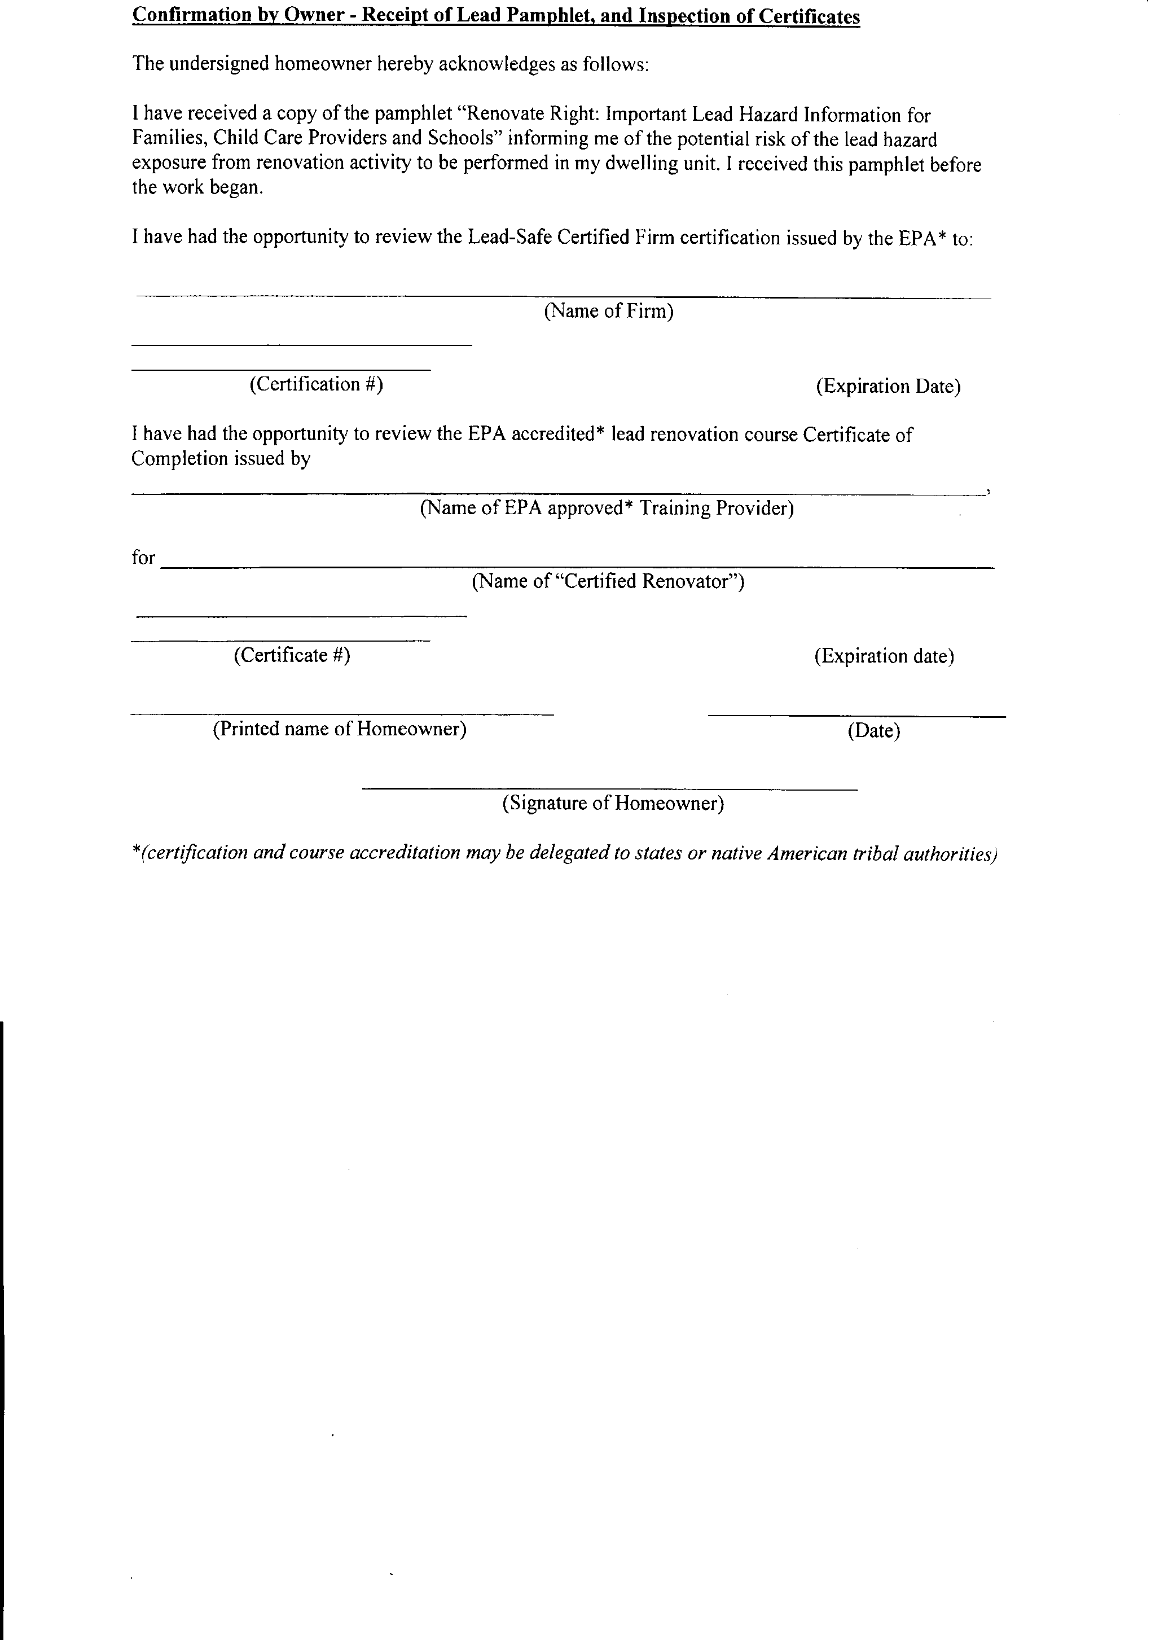

|  |
| --- |
| **Cipriani Builders Inc. t/a CIPRIANI REMODELING SOLUTIONS** |
| |  | | --- | | **1/15/2020**  **NAT-19527-1** | |
|  |
| **Access Training Services, Inc.** |
| **Mark Simone** |
| **R-1-18846-10-00037** |
| **1/15/20** |
|  |
|  |
|  |
|  |

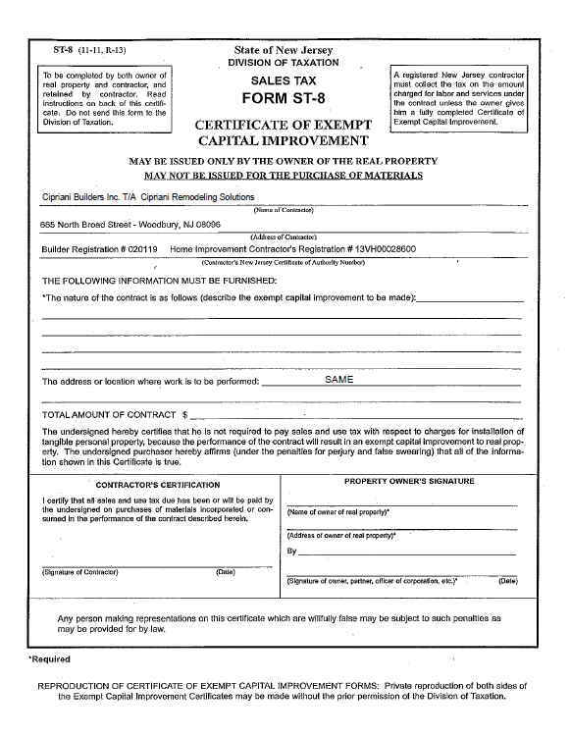

$98,830.60

Kitchen and Powder Room Remodel

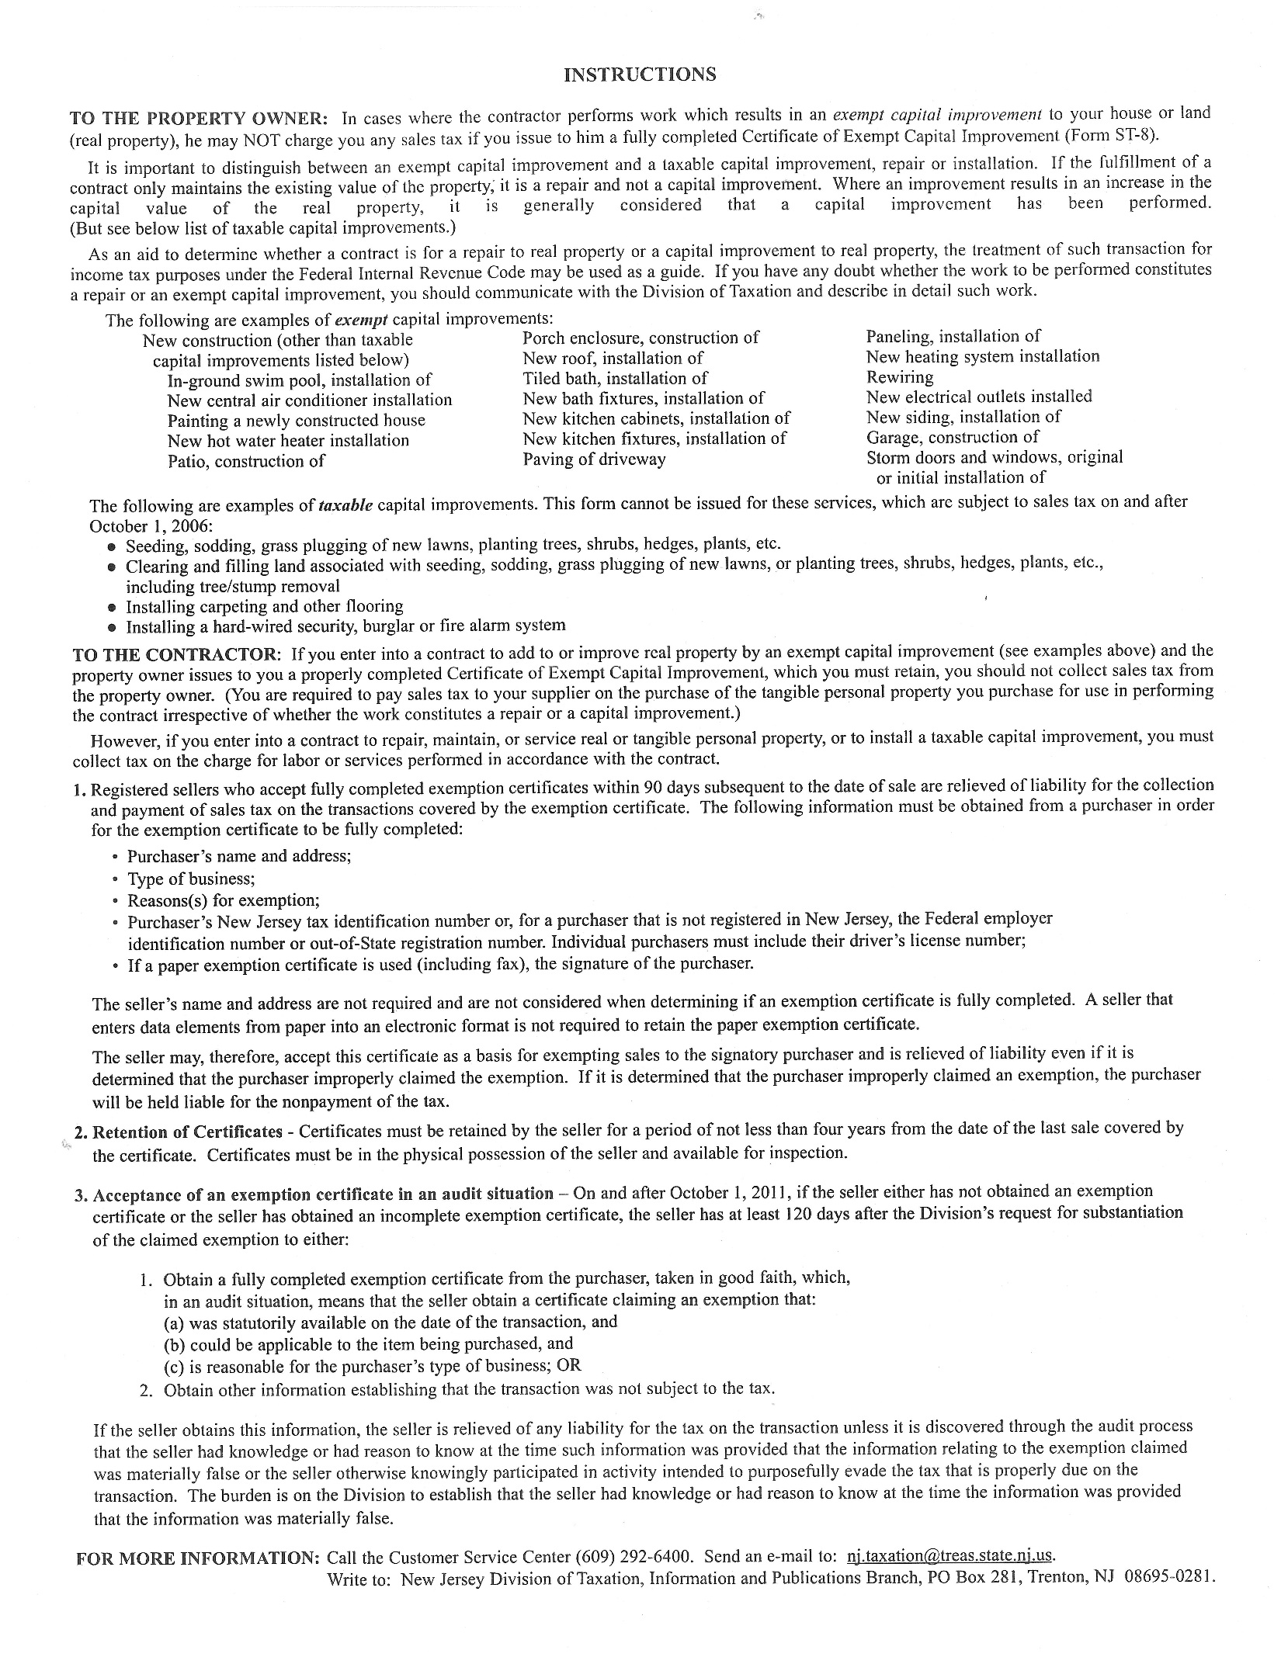

M:\Scans\20151224115954268_0001.tif



